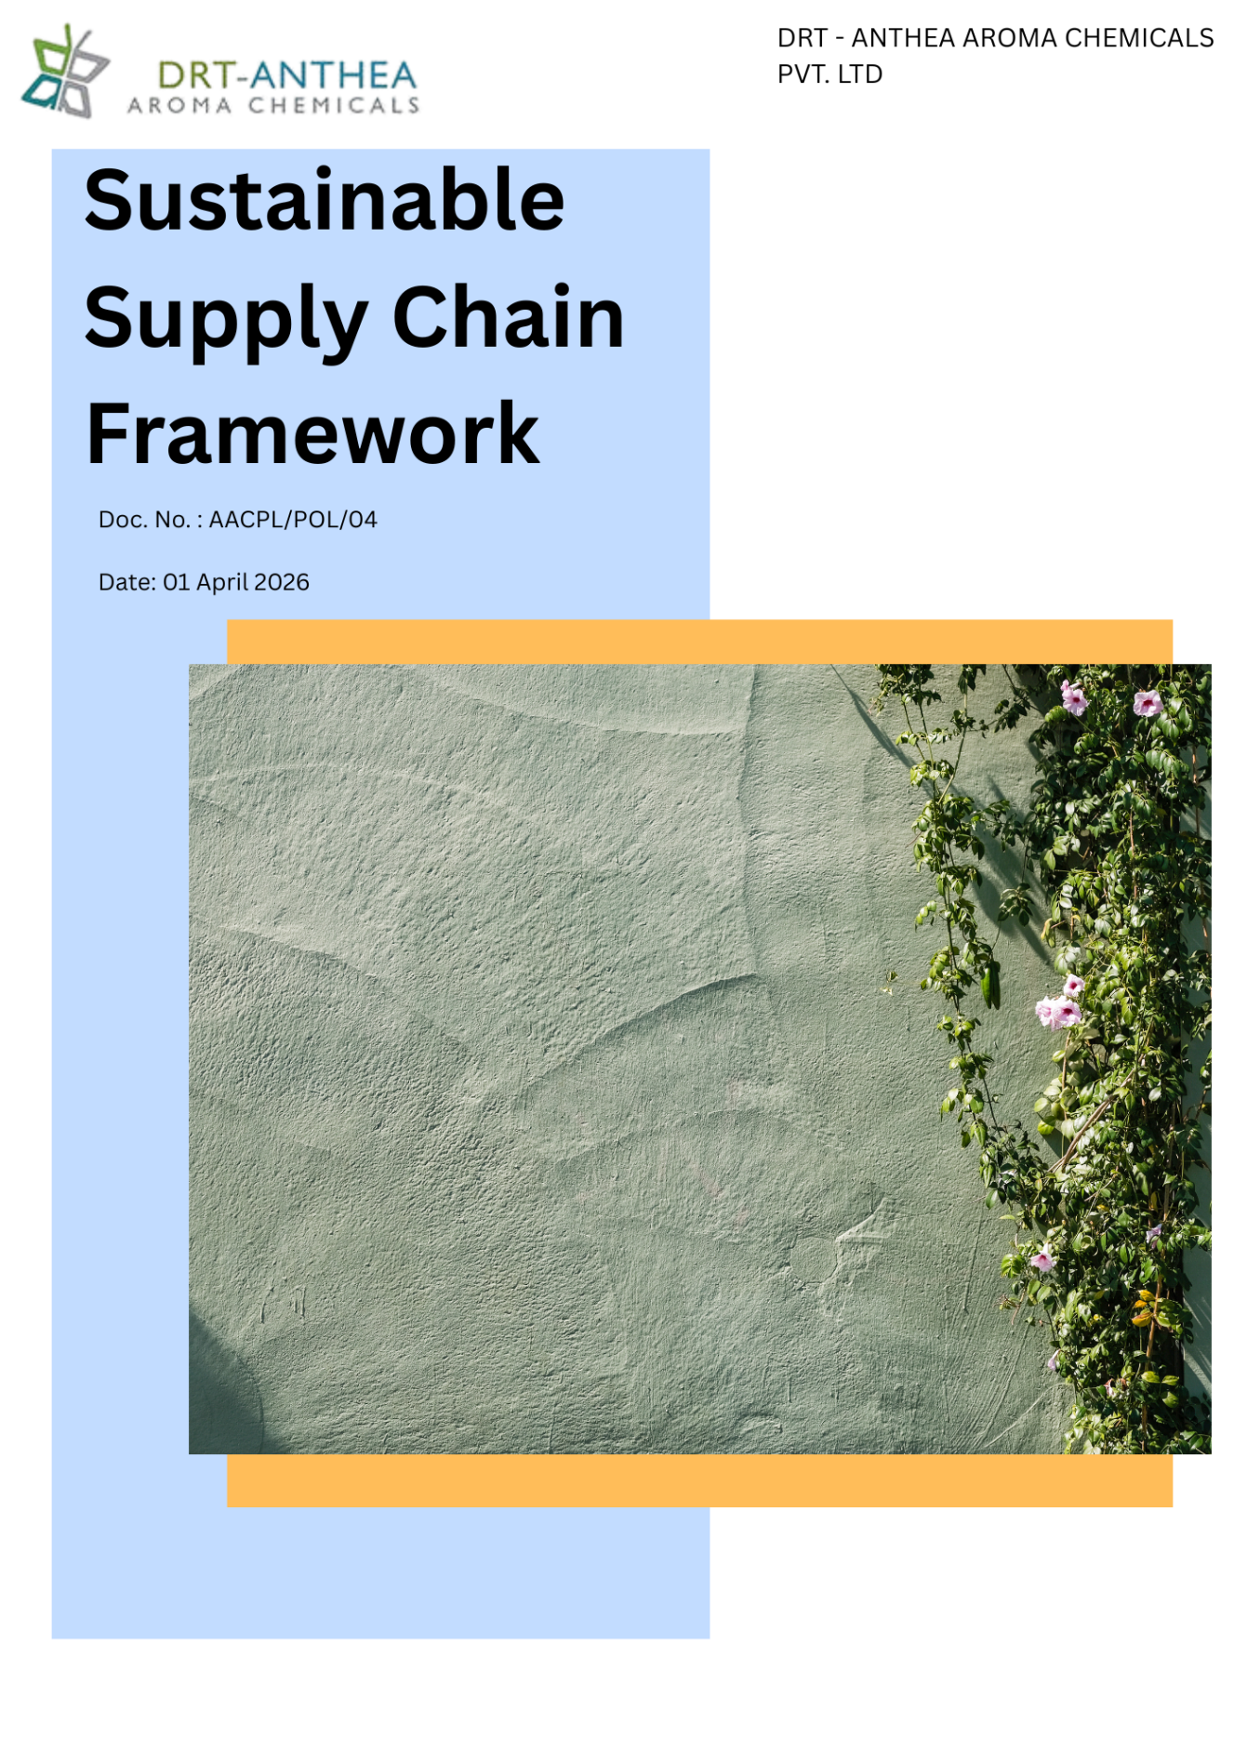

Table of Contents
List of Abbreviations: 3
1. Alignment with Anthea Group Sustainable Supply Chain Framework 4
2. Introduction 4
3. Objective 4
4. Scope 5
4. Key Performance Areas 6
4.1 Sustainable Procurement and Responsible Sourcing 6
4.2 Supplier Environmental Practices 6
4.3 Supplier Social Practices 6
4.4 Supplier Ethics and Governance 6
4.5 Supplier Performance, Risk Management and Continuous Improvement 6
5. Commitments and Qualitative Targets 7
5.1 Supplier Environmental Practices 7
5.2 Supplier Social and Labour Practices 8
5.3 Sustainable Procurement Goals 9
5.4 Governance Goals 9
6. Governance and Responsibilities 10
7. Reporting 10
8. Policy Alignment with SDGs 11
9. Review Mechanism 11
10. Employee Acknowledgement Form 12

List of Abbreviations:

Abbreviation | Full Form
ESG | Environmental, Social and Governance
EHS | Environment, Health & Safety
EMS | Environmental Management System
GHG | Greenhouse Gas
HR | Human Resources
FY | Financial Year
KPI | Key Performance Indicator
ISO | International Organization for Standardization
PPE | Personal Protective Equipment
CAPA | Corrective and Preventive Action
SDGs | Sustainable Development Goals
MIDC | Maharashtra Industrial Development Corporation

Alignment with Anthea Group Sustainable Supply Chain Framework
To support and align with the sustainability vision, responsible sourcing commitments, and strategic objectives of the Anthea Group, DRT-Anthea Aroma Chemicals Pvt. Ltd. has established this Sustainable Supply Chain Framework as a comprehensive approach for managing environmental, social, ethical, and governance considerations throughout its supply chain. The Framework promotes responsible procurement, supplier engagement, ethical sourcing, environmental stewardship, human rights, labour standards, and compliance with applicable laws and internationally recognized standards.
To facilitate the effective implementation of this Framework, the Company has also developed an internal Sustainable Supply Chain Roadmap, which translates the Group's responsible sourcing priorities into site-specific objectives, targets, action plans, and performance monitoring mechanisms. This Roadmap supports the continuous enhancement of supplier sustainability performance, responsible procurement practices, supply chain resilience, risk management, and collaborative value creation, while reinforcing the Company's commitment to responsible and sustainable business operations.

Introduction
DRT-Anthea Aroma Chemicals Pvt. Ltd. recognizes that sustainable procurement is a key driver of responsible business growth and long-term value creation. As a manufacturer of specialty aroma chemicals, the Company is committed to integrating environmental, social, ethical, and governance (ESG) considerations into its procurement processes to ensure that goods, materials, and services are sourced in a responsible, transparent, and sustainable manner.
This Sustainable Supply Chain Framework establishes the Company's commitment to working collaboratively with suppliers, contractors, and service providers who share its values of environmental stewardship, ethical business conduct, respect for human rights, and regulatory compliance. Through responsible sourcing practices, supplier engagement, risk-based assessments, and continual improvement, DRT-Anthea Aroma Chemicals Pvt. Ltd. aims to strengthen the sustainability and resilience of its supply chain while creating positive value for its customers, employees, business partners, and the communities in which it operates.

Objective
The objective of this Sustainable Supply Chain Framework is to establish a framework for integrating environmental, social, ethical, and governance (ESG) principles into the procurement activities of DRT-Anthea Aroma Chemicals Pvt. Ltd. and to promote responsible sourcing practices across its supply chain.
This policy aims to:
- Ensure that procurement decisions consider environmental, social, ethical, quality, and business continuity aspects in addition to cost and performance.
- Promote responsible sourcing by engaging suppliers who demonstrate compliance with applicable legal, regulatory, environmental, labour, human rights, and ethical requirements.
- Encourage suppliers to adopt sustainable environmental practices, including efficient resource utilization, pollution prevention, waste reduction, climate action, and responsible chemical management.
- Foster fair labour practices, respect for human rights, occupational health and safety, diversity, equity, and inclusion throughout the supply chain.
- Promote ethical business conduct by preventing bribery, corruption, conflicts of interest, fraud, and other unethical practices within procurement activities.
- Strengthen supplier sustainability performance through risk-based assessments, supplier evaluations, audits, corrective action plans, and continuous engagement.
- Build long-term partnerships with suppliers that support innovation, transparency, resilience, and continual improvement in sustainability performance.
- Contribute to the Company's sustainability objectives while creating long-term value for customers, employees, suppliers, and other stakeholders.

Scope
This Sustainable Supply Chain Framework applies to all procurement activities of DRT-Anthea Aroma Chemicals Pvt. Ltd. and is applicable to all employees involved in purchasing and sourcing decisions, as well as suppliers, contractors, service providers, consultants, logistics partners, and other business associates engaged by the Company.
The scope of this policy covers all operational locations of the Company, including:
- Unit I: Plot Nos. 49, 50 & 51 A, MIDC Dhatav, Roha, Dist. Raigad – 402116, Maharashtra, India.
- Unit II: Plot No. 51 A/1, Roha Industrial Area, Village Roth Budruk, Roha, Dist. Raigad – 402116, Maharashtra, India.
The policy establishes the minimum sustainability expectations for suppliers by promoting responsible environmental practices, ethical business conduct, respect for human rights and labour standards, regulatory compliance, and continual improvement. DRT-Anthea Aroma Chemicals Pvt. Ltd. encourages its suppliers and business partners to align with the principles outlined in this policy and work collaboratively towards building a responsible, transparent, and sustainable supply chain.

4. Key Performance Areas
To support responsible sourcing and strengthen supply chain sustainability, DRT-Anthea Aroma Chemicals Pvt. Ltd. shall focus on the following key performance areas:

4.1 Sustainable Procurement and Responsible Sourcing
Promote sustainable procurement practices by integrating environmental, social, ethical, quality, risk, and business continuity considerations into supplier selection, evaluation, and purchasing decisions.

4.2 Supplier Environmental Practices
Encourage suppliers to adopt environmentally responsible practices, including efficient resource utilization, climate change mitigation, pollution prevention, water conservation, responsible chemical management, waste minimization, and compliance with applicable environmental laws and standards.

4.3 Supplier Social Practices
Promote respect for human rights, fair labour practices, occupational health and safety, diversity, equity and inclusion, employee welfare, and compliance with applicable labour laws throughout the supply chain.

4.4 Supplier Ethics and Governance
Promote ethical business conduct by encouraging suppliers to maintain high standards of integrity, transparency, anti-bribery and anti-corruption practices, conflict of interest management, regulatory compliance, data confidentiality, and responsible corporate governance.

4.5 Supplier Performance, Risk Management and Continuous Improvement
Strengthen supply chain resilience by conducting supplier sustainability assessments, monitoring supplier performance, managing procurement-related risks, implementing corrective action plans where necessary, and fostering collaboration for continual improvement in sustainability performance.

Commitments and Qualitative Targets
Baseline Year: FY 2023-24
DRT-Anthea Aroma Chemicals Pvt. Ltd. is committed to promoting responsible and sustainable procurement practices by integrating environmental, social, labour, ethical, and governance considerations into its supply chain management. The Company shall pursue the following commitments:

5.1 Supplier Environmental Practices
Objective | Commitment | Target (Baseline Year: FY 2023-24) | Key Actions
Environmental Compliance | Encourage suppliers to comply with applicable environmental laws and regulations | Assess 100% of strategic suppliers for environmental compliance by FY 2029-30 | Supplier evaluations, self-assessments and periodic reviews
Environmental Management | Promote the adoption of environmental management systems | Have 15-% of strategic suppliers to implement or maintain an Environmental Management System (e.g., ISO 14001) by FY 2029-30 | Supplier engagement, awareness programs and capability building
Climate & Resource Efficiency | Encourage suppliers to improve energy efficiency, reduce GHG emissions, and conserve natural resources | Engage 30% of strategic suppliers on climate and resource efficiency initiatives by FY 2029-30 | Sustainability questionnaires, supplier discussions and performance reviews
Sustainable Procurement Capacity Building | Strengthen the environmental knowledge and competencies of the procurement team to integrate sustainability into supplier selection and engagement | Provide annual environmental sustainability training to 100% of procurement employees by FY 2029-30 | Conduct training programs on sustainable procurement, supplier environmental requirements, climate risks
Local Sourcing & Emissions Reduction | Increase procurement from local suppliers to reduce transportation-related greenhouse gas emissions and support regional economic development | Increase procurement spend from local suppliers by 20% by FY 2029-30 | Prioritize qualified local suppliers during sourcing, evaluate transportation impacts in procurement decisions, and monitor local sourcing performance annually
Environmental Performance Improvement | Drive continual improvement in supplier environmental performance | Conduct annual sustainability performance reviews for strategic suppliers | Supplier scorecards, feedback meetings and improvement programs

5.2 Supplier Social and Labour Practices
Objective | Commitment | Target (Baseline Year: FY 2023-24) | Key Actions
Responsible Supplier Selection | Integrate occupational health and safety criteria into supplier selection and evaluation | Increase the proportion of strategic suppliers with ISO 45001 or equivalent Occupational Health & Safety certification to 30% by FY 2029-30 | Include ISO 45001 (or equivalent) as a preferred supplier evaluation criterion, encourage certification adoption, and monitor supplier certification status annually
Human Rights | Promote respect for internationally recognized human rights across the supply chain | Assess 100% of strategic suppliers against the Company's human rights expectations by FY 2029-30 | Supplier Code of Conduct, self-assessments and due diligence
Labour Practices | Encourage fair labour practices and prohibit child labour, forced labour and discrimination | Obtain acknowledgement of the Supplier Code of Conduct from 100% of new strategic suppliers | Contractual requirements, supplier onboarding and periodic reviews
Occupational Health & Safety | Encourage suppliers to provide safe and healthy workplaces | Evaluate occupational health and safety practices of high-risk suppliers by FY 2029-30 | Supplier audits, performance monitoring and corrective actions
Sustainable Procurement Capacity Building | Strengthen the procurement team's understanding of social sustainability and responsible sourcing practices | Provide annual social sustainability training to 100% of procurement employees by FY 2029-30 | Conduct training on human rights, labour standards, supplier social assessments, modern slavery
Responsible Supplier Selection & Local Sourcing | Promote procurement from local and socially responsible suppliers while integrating occupational health and safety criteria into supplier selection | Increase procurement spend from local suppliers by 20% | Prioritize qualified local suppliers where fesible

5.3 Sustainable Procurement Goals
Objective | Commitment | Target (Baseline Year: FY 2023-24) | Key Actions
Responsible Sourcing | Integrate sustainability considerations into procurement decisions | Include sustainability criteria in 100% of strategic sourcing decisions by FY 2029-30 | Sustainable procurement procedures and supplier evaluation criteria
Supplier Sustainability Assessment | Strengthen sustainability due diligence across the supply chain | Conduct sustainability assessments for 100% of strategic suppliers by FY 2029-30 | Risk assessments, supplier questionnaires and periodic reviews
Local & Responsible Procurement | Promote responsible procurement from qualified local and regional suppliers where feasible | Increase procurement from compliant local suppliers, where technically and commercially feasible, by FY 2029-30 | Supplier development, local sourcing initiatives and performance monitoring
Supplier Code of Conduct | Ensure suppliers understand and commit to the Company's sustainability, ethical, and compliance expectations | Obtain acceptance of the Supplier Code of Conduct from 100% of strategic suppliers by FY 2029-30 | Communicate the Supplier Code of Conduct, obtain signed acknowledgements,
ESG Contractual Integration | Integration  Integrate environmental, social, and governance (ESG) requirements into supplier agreements | Include ESG clauses in 70% of strategic supplier contracts by FY 2029-30 | Incorporate ESG provisions into procurement contracts, update standard contract templates,

5.4 Governance Goals
Objective | Commitment | Target (Baseline Year: FY 2023-24) | Key Actions
Risk Management | Strengthen governance through risk-based supplier management | Conduct sustainability risk assessments for 100% of high-risk suppliers annually | Risk assessment methodology, supplier categorization and mitigation plans
Procurement staff training | Aim to tarin our procurement employees on governance issues associated with procurement | 100% on employee trained on the governance issues associated with procurement | Conduct regular training

Governance and Responsibilities
Effective implementation of this Sustainable Supply Chain Frameworkrequires active participation and accountability across all levels of DRT-Anthea Aroma Chemicals Pvt. Ltd. The roles and responsibilities are defined as follows:
Role | Key Responsibilities
Executive Management | • Provide strategic direction and approve the Green Procurement Policy.  • Allocate adequate resources for effective implementation.  • Review procurement sustainability performance and support continual improvement initiatives.
Procurement Department | • Implement the Sustainable Supply Chain Frameworkin all sourcing and purchasing activities.  • Integrate environmental, social, labour, ethical, and governance (ESG) criteria into supplier selection, evaluation, and contract management.  • Conduct supplier sustainability assessments and maintain procurement records.
EHS (Environment, Health & Safety) Department | • Support the evaluation of suppliers on environmental performance and regulatory compliance.  • Provide technical guidance on environmental sustainability requirements and participate in supplier audits where applicable.
Quality Assurance Department | • Verify that procured materials and services meet applicable quality, regulatory, and customer requirements.  • Support supplier qualification, performance monitoring, and continuous improvement activities.
Employees Involved in Procurement | • Comply with this policy and applicable procurement procedures.  • Conduct procurement activities ethically, transparently, and responsibly.  • Report any non-compliance, unethical practices, or sustainability concerns related to suppliers.
Suppliers, Contractors & Service Providers | • Comply with applicable legal, environmental, labour, health & safety, and ethical requirements.  • Support the Company's sustainability expectations and participate in assessments, audits, and continual improvement initiatives where applicable.

Reporting
DRT-Anthea Aroma Chemicals Pvt. Ltd. shall establish and maintain a systematic process for monitoring and reporting the implementation and effectiveness of this Green Procurement Policy. Reporting shall include supplier sustainability assessments, supplier environmental and social performance, procurement-related ESG indicators, supplier audits, corrective action plans, training activities, and compliance with applicable legal, regulatory, and Company requirements.
The Procurement Department, in coordination with relevant functions, shall periodically review supplier sustainability performance and report progress against the Company's sustainable procurement objectives and targets to the Management. Relevant records and documentation shall be maintained to support internal audits, customer requirements, management reviews, regulatory compliance, and continual improvement of the sustainable procurement program.

Policy Alignment with SDGs




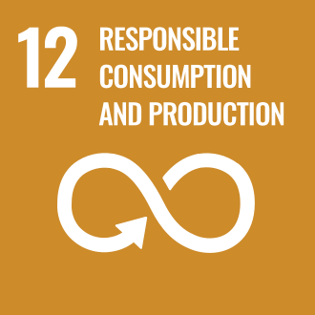


Review Mechanism
This Sustainable Supply Chain Framework shall be reviewed at least once every year, or earlier if required due to changes in applicable laws and regulations, business operations, supply chain risks, stakeholder expectations, or the Company's sustainability objectives. The review shall ensure that the policy remains relevant, effective, and aligned with the Company's sustainable procurement commitments and business strategy.
The review shall be coordinated by the Procurement Department, in consultation with relevant functions, and approved by the Management. Any revisions to the policy shall be communicated to all relevant employees, suppliers, contractors, and other applicable stakeholders to support effective implementation and continual improvement of the Company's sustainable procurement practices.
Authorized by:

Legal & Compliance Head
DRT – Anthea Aroma Chemicals Pvt. Ltd.

Employee Acknowledgement Form
I acknowledge that I have read, understood, and agree to comply with the Sustainable Supply Chain Frameworkof DRT-Anthea Aroma Chemicals Pvt. Ltd. I understand my responsibility to support the Company's sustainable procurement commitments by conducting procurement activities ethically, responsibly, and in accordance with applicable laws, Company policies, and sustainability requirements.
I further acknowledge that I will promote responsible sourcing practices, consider environmental, social, labour, ethical, and governance (ESG) factors in procurement decisions, report any actual or suspected non-compliance, and contribute to the continual improvement of the Company's sustainable procurement program.

Employee Name: _______________________________________
Employee ID: _________________________________________
Department: __________________________________________
Designation: _________________________________________
Signature: ___________________________________________
Date: ________________________________________________

